#### **INTRODUCTION**

The displacement crisis of the Rohingya people has emerged as one of the most pressing humanitarian challenges of the 21st century. With nearly 1,000,000 Rohingya refugees (United Nations High Commissioner for Refugees, n.d.) currently residing in makeshift camps in Bangladesh, there is an urgent need for innovative solutions that not only provide basic accommodation but also promote productivity and self-sufficiency (Milton et al., 2017). This paper explores the conceptual development of an intelligent accommodation system for Rohingya refugees, integrating sustainable living conditions with opportunities for economic and social productivity while ensuring security by utilizing the capabilities of artificial intelligence (AI).

#### **Problem Background**

The Rohingya, an ethnic minority from Myanmar, have faced decades of systemic persecution, leading to mass displacement. The influx of refugees into Bangladesh, particularly in the Cox’s Bazar region, has placed immense pressure on resources and infrastructure. Traditional refugee camps often focus solely on providing immediate relief, such as food and shelter, without addressing long-term sustainability and the potential for refugees to contribute economically and socially (Bhatia et al., 2018).

To illustrate the gravity of the situation, consider the story of Tasmin, a 51-year-old Rohingya woman who fled Myanmar’s Rakhine State after horrific violence was waged against her ethnic minority group in late 2017. Tasmin and her five children escaped to the forests behind their home, hiking for eleven days before reaching the Naf River, which marks the border between Myanmar and Bangladesh. Tasmin’s family was resettled in Kutupalong, where they joined nearly one million other Rohingya refugees. Tasmin's story reflects the extreme trauma and severe hardships that all Rohingya refugees endure in these overcrowded camps, where they face dire living conditions, including inadequate shelter, food shortages, and a lack of basic sanitation and healthcare (Relief International, 2019).

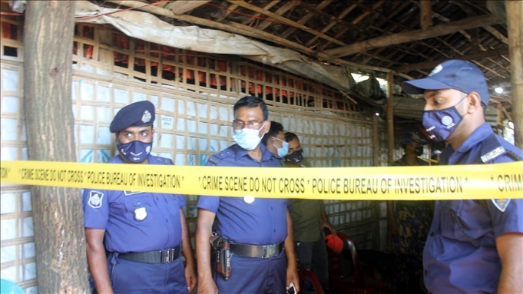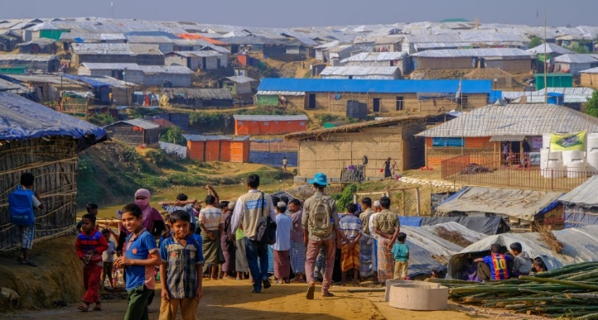

Figure 1: Kutupalong Refugee Camp (Humanity & Inclusion Canada, n.d.)

Figure 2 - Bangladesh police stand guard in front of the madrassa at the Balukhali refugee camp where six Rohingya were killed in an attack on Oct. 22, in the Ukhia sub-district of Cox’s Bazar, Oct. 26, 2021. (Benar News, 2021)

Adding to these challenges, an alarming rise in crimes within the camps, including murders and

drug-related offenses, has been reported. These crimes are often linked to the activities of armed groups such as the Arakan Rohingya Salvation Army (ARSA) and the Arakan Solidarity Organization (RSO; The Daily Star, 2023). Moreover, the issue of Rohingya refugees obtaining fake Bangladeshi identification documents further complicates the security dynamics within the camps, creating an environment of instability and fear (Dhaka Tribune, 2023). The rise in crimes can be attributed to several factors, including the lack of economic opportunities and the pervasive sense of hopelessness among refugees. Many jobless youths, facing severe economic deprivation, become involved in criminal activities as a means of survival. Additionally, competition among armed groups for control over illegal activities such as drug trafficking and extortion fuels further violence and instability within the camps (Dhaka Tribune, 2023).

The problems that this research aims to address can be broadly summarized into two main issues:

* **Inadequate living conditions and lack of long-term sustainability**: Current refugee accommodations hinder the economic self-sufficiency and social productivity of Rohingya refugees.
* **Escalating security problems within camps**: Issues such as crime and the misuse of identification documents further destabilize the already precarious environment.

This paper addresses the critical need to rethink refugee accommodation from a perspective that includes productivity, self-reliance, and enhanced security.

#### **Related Studies**

The conditions within Rohingya refugee camps have been the subject of various academic studies, each shedding light on different aspects of the refugee crisis. For instance, Bhatia et al. (2018) provide an in-depth analysis of the living conditions in the camps, emphasizing the inadequacy of basic facilities and the lack of economic opportunities. Their study highlights the dire need for improved infrastructure and sustainable living conditions but falls short of proposing actionable solutions for long-term self-sufficiency and economic integration.

Similarly, Milton et al. (2017) focus on the health challenges faced by the Rohingya refugees due to overcrowding and poor sanitation. While this study offers valuable insights into the public health crises within the camps, it does not explore the broader socio-economic factors contributing to these conditions or how technology could mitigate them.

The research by Ahmed et al. (2019) further explores the status of Rohingya refugees in Bangladesh, highlighting the extreme hardships they endure, including inadequate shelter and limited access to education and healthcare. However, like previous studies, it does not address the potential for integrating technological solutions to improve the overall quality of life and security within the camps.

Hossain et al. (2020) delve into the security issues within the camps, particularly focusing on the rise in crimes and the involvement of armed groups. Their research underscores the complex security dynamics in the camps but does not consider how AI and other advanced technologies could be leveraged to enhance security and stabilize the environment.

Despite the valuable contributions of these studies, there is a noticeable gap in the literature regarding integrated solutions that combine sustainable living conditions with productivity-enhancing features and advanced technologies like AI. None of the existing research comprehensively addresses the need for a holistic accommodation system that not only meets the basic needs of refugees but also empowers them to achieve economic self-sufficiency and social productivity while ensuring their security.

This research aims to fill that gap by proposing an intelligent accommodation system that incorporates AI to optimize resource allocation, enhance security, and support economic integration within the refugee camps. By addressing these gaps, this study will contribute significantly to the field of humanitarian aid and refugee studies, offering a model that can be adapted and implemented in similar contexts globally.

#### **Research Objectives**

This research proposes an intelligent accommodation system for Rohingya refugees that integrates sustainable living conditions, productivity opportunities, and enhanced security. The goal is to create a framework addressing both immediate needs (shelter, sanitation, healthcare) and long-term sustainability (environmental practices, resource availability). Economic activities will be incorporated, promoting refugee self-reliance and transforming camps into productive communities. To address security issues like crime and armed group influence, the framework will leverage AI to enhance security measures and optimize resource allocation. Though the study does not aim to implement the system, it will offer a conceptual model answering: " **How to develop an intelligent accommodation system for Rohingya refugees that facilitates productivity, ensures security, and leverages AI?**"

#### **Research Contributions**

This study contributes to humanitarian aid, refugee studies, and AI-driven social innovation by presenting a framework for intelligent accommodation systems tailored to Rohingya refugees. It provides insights for policymakers and organizations on using AI to create sustainable, secure environments while enhancing refugee productivity. By integrating AI in resource management and security, the research offers solutions that reduce refugee dependency, promote self-sufficiency, and alleviate the socio-economic burden on host countries.

#### **METHODOLOGY**

The methodology of this study is based on a systematic literature review (SLR) approach, designed to comprehensively evaluate existing research and literature relevant to the development of intelligent accommodation systems for Rohingya refugees. This approach ensures a thorough and unbiased collection of data that contributes to forming a robust framework for addressing the research problem. The SLR method follows the guidelines set by Kitchenham et al. (2010) and Petersen et al. (2008), which emphasize the importance of systematic data collection and analysis.

#### 3.1 Search Strategy

The search strategy employed in this study was designed to locate the most relevant academic and scholarly sources across multiple databases. The selected databases include IEEE Xplore, SpringerLink, ScienceDirect, ACM Digital Library, IGI Global, Google Scholar, and Wiley Online Library. These databases offer extensive coverage of technological and humanitarian literature, essential for the interdisciplinary nature of this research.

#### 3.1.1 Keywords and Boolean Logic

A combination of carefully selected keywords was utilized to refine and target the search results. Boolean operators were applied to manage and expand the search results effectively. The following keywords and Boolean logic were used:

* "Rohingya refugees" AND "accommodation system" AND "artificial intelligence"
* "refugee productivity" OR "sustainable refugee camps"
* "AI in refugee security" AND "systematic review"

This strategic combination of search terms helped ensure the search was both comprehensive and focused on relevant studies.

#### 3.1.2 Forward and Backward Search Techniques

In addition to the primary search using databases, both forward and backward citation search techniques were employed. This included reviewing the references cited in key articles (backward search) as well as identifying more recent publications that cited these articles (forward search). This approach ensured that all relevant literature, including the most recent studies, was considered in the review process. This comprehensive search strategy minimizes the risk of omitting any critical studies or emerging research.

#### 3.2 Inclusion and Exclusion Criteria

To ensure the relevance and quality of the reviewed literature, specific inclusion and exclusion criteria were applied throughout the selection process.

### *3.2.1 Inclusion Criteria*

* Peer-reviewed journal articles and conference papers.
* Studies focusing on refugee accommodation, AI applications in humanitarian settings, and security.
* Publications in English.
* Articles published between 2000 and 2024.
* Studies that included abstract or title discussions relevant to refugee accommodation systems or AI in humanitarian settings.

#### 3.2.2 Exclusion Criteria

* Non-peer-reviewed articles, such as opinion pieces or editorials.
* Studies not explicitly addressing AI or accommodation systems in refugee contexts.
* Articles where only titles were relevant but lacked substance in abstracts or full texts.
* Publications without sufficient detail or methodological rigor.

#### 3.3 Selection Process

The selection process was designed to systematically screen studies based on their relevance to the research question

#### 3.3.1 Initial Screening

An initial search of the academic databases yielded 87 articles after applying the defined keywords. Titles and abstracts of these papers were reviewed to determine their relevance to the research question. This initial screening was based on whether the articles mentioned AI, refugee accommodation, and security systems, among other factors.

#### 3.3.2 Secondary Filtering

Following the initial screening, the inclusion and exclusion criteria were applied to refine the list. This stage involved filtering out studies that lacked peer-reviewed rigor or relevance to AI-driven accommodation systems for Rohingya refugees. After this stage, 30 articles remained for further review.

#### 3.3.3 Final Selection

A detailed review was conducted on the remaining 30 articles, which led to a final selection of 13 studies. These were chosen based on their direct relevance to the research objectives, as well as their methodological rigor. Both free full-text articles and those available only through abstracts were considered in this review, with abstracts used to extract data when full texts were not accessible.

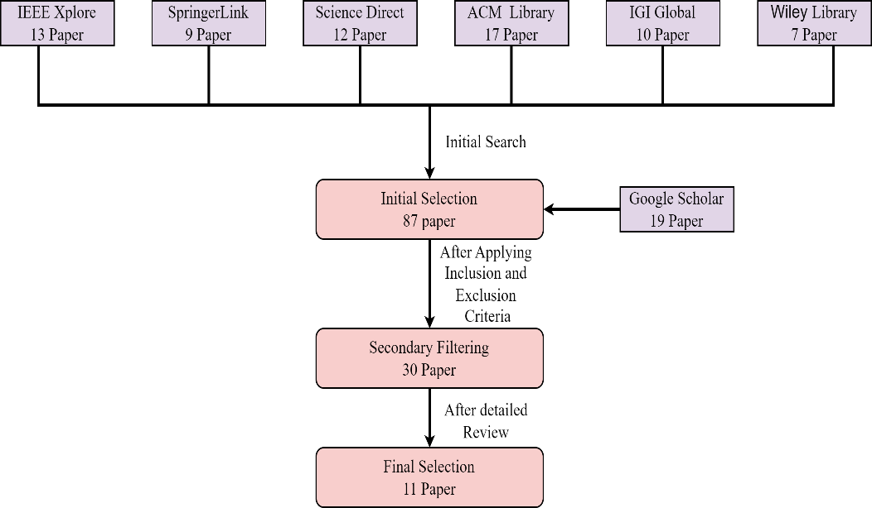

**Figure 3** Literature Search and Article Selection for Systematic Review

#### 3.4 Data Extraction and Synthesis

Data extraction was performed with a standardized approach to ensure consistency. For freely available articles, detailed information was gathered from all sections including the abstract, methodology, results, and discussion. For articles where only abstracts were accessible, data extraction focused on the abstracts. This method facilitated a broad review of available literature while acknowledging the limitations imposed by paywalls.

#### 3.4.1 Data Extraction Process

A standardized data extraction form was used to methodically collect information from each study. For fully accessible articles, comprehensive data were extracted across all sections: abstract, introduction, methodology, results, and conclusions. This thorough examination was aimed at obtaining a holistic understanding of each study's contributions. For articles limited to abstracts, the extraction focused on gleaning the most significant points that related to the research objectives of developing an intelligent accommodation system for Rohingya refugees.

#### 3.4.2 Thematic Synthesis

The information extracted was then analyzed thematically, grouping studies into relevant themes such as "AI applications in refugee settings," "security enhancement through technology," and "initiatives for economic productivity." This synthesis helped identify prevalent trends, highlight significant gaps, and pinpoint emerging opportunities within the research area.

#### 3.4.3 Quality Assessment

Quality assessment was performed on the selected studies based on criteria including citation count, publication in high-impact journals, and the rigor of the methodology employed. This rigorous assessment ensured that only high-quality studies were included in the synthesis, enhancing the credibility and impact of the research findings.

results and analysis

***a. Research Data***

|  |
| --- |
|  |
| **Alam, F. R., Munir, M. B., Ishrak, S., Hussain, S., Reza, F., Khan, N. S., Tumpa, S. N. & Karim, M. M. (2018). *An automated cloud-based digitized management system for Rohingya refugee camp in Bangladesh.* 2018 International Conference on Electrical, Computer, and Communication Engineering (ECCE), Chonburi, Thailand.** |
| The paper outlines a cloud-based digitized management system that aims to enhance the organization and efficiency of refugee accommodation by providing a centralized database for tracking resources, services, and individual refugee information. Key findings include the importance of unique identification for each refugee, which can improve security and facilitate better resource allocation, ultimately fostering a more productive environment for both refugees and management organizations. Additionally, the proposed system emphasizes the need for biometric identification to enhance trustworthiness and security in managing refugee data. |
| **Wardeh, M., & Marques, R. C. (2021). Sustainability in refugee camps: A systematic review and meta-analysis. *Sustainability*, *13*(14), 7686** |
| The systematic review highlights the need for sustainable planning and development in refugee camps, emphasizing the importance of integrating local knowledge and technology to create secure and productive living environments. It identifies health and well-being, education, and economic growth as critical sectors for intervention, suggesting that a long-term vision and tailored policies are essential for improving the quality of life for refugees, including the Rohingya community. |
| **Dala, A., Darweesh, A., Misselwitz, P., & Steigemann A. (2018). Planning the Ideal Refugee Camp A Critical Interrogation of Recent Planning Innovations in Jordan and Germany. *Urban Planning, 3*(4), 64** |
| The paper highlights the need for improved shelter design in refugee camps, emphasizing the importance of integrating urban planning principles to enhance both productivity and security. It critiques the bureaucratic nature of existing systems, suggesting that more flexible and self-determined living arrangements can empower refugees. The experiences from Berlin and Jordan illustrate that while innovative designs can foster community and autonomy, they often fall short in providing genuine agency and control for residents, which is crucial for a productive and secure environment for the Rohingya refugees. |
| **Sabie, D., & Ahmed, S. I. (2019). *Moving into a technology land: exploring the challenges for the refugees in Canada in accessing its computerized infrastructures.* COMPASS '19: Proceedings of the 2nd ACM SIGCAS Conference on Computing and Sustainable Societies, Accra, Ghana.** |
| The paper highlights that refugees face significant challenges in accessing technology and information, which affects their productivity and security. It emphasizes the need for inclusive design in technology that considers low literacy levels and cultural constraints, particularly for women. Addressing these issues through an intelligent accommodation system could enhance access to resources, improve digital skills, and ensure a safer environment for Rohingya refugees, ultimately facilitating their integration and productivity in the host community. |
| **Marji, N., & Kohout, M. (2022). *From Temporary Shelter to Permanent Dwelling: Optimizing the Spatial Organization of Refugee Camps in Jordan through Artificial Intelligence.* Academic Mindtrek 2022: 25th International Academic Mindtrek conference, Tampere, Finland.** |
| The paper highlights the need for adaptive planning in refugee camps, emphasizing the importance of integrating artificial intelligence to enhance spatial organization. It suggests that intelligent accommodation systems can improve living conditions by facilitating self-determination and productivity among refugees while ensuring security through better resource management and infrastructure planning. The findings indicate that a participatory |
| **Hossain, S. M., Zhang, H., Hossain, M. S., & Yun, L. (2020). Rohingya Refugee Crisis: Security Concerns for Bangladesh. *South Asian Journal of Social Studies and Economics 8*(2), 24-34.** |
| The paper highlights the urgent need for a structured approach to the Rohingya refugee crisis, emphasizing the importance of ensuring security and facilitating the safe return of refugees. It identifies the vulnerabilities faced by Rohingyas due to their irregular status and limited access to resources, which could inform the development of an intelligent accommodation system that enhances productivity while addressing security concerns through proper management and integration strategies. Additionally, the need for international cooperation and humanitarian support is crucial for creating a sustainable environment for the refugees. |
| **Easen, O., & Binatli, A. O. (2017). The Impact of Syrian Refugees on the Turkish Economy: Regional Labour Market Effects. *Social Sciences, 6*(4), 129** |
| The paper highlights that the influx of refugees, such as the Syrian population in Turkey, significantly impacts local labor markets, often leading to increased unemployment and informal employment. It emphasizes the need for effective integration strategies to enhance productivity and ensure security for refugees. These insights can inform the development of an intelligent accommodation system for Rohingya refugees by focusing on labor market integration and the provision of secure living conditions to foster productivity and stability in their communities. |
| **İncetahtacı, N. (2024). The role of university-NGO cooperation in increasing the entrepreneurial skills of youth: An evaluation specific to refugee youth. *International Journal of Education, 39*(2), 507-523.** |
| The study highlights that enhancing the productivity of refugee youth involves addressing challenges such as limited access to resources, legal complexities, and cultural barriers. It emphasizes the role of collaborative initiatives between universities and NGOs in providing essential training and mentorship, which can empower refugees and improve their economic contributions. Additionally, fostering social cohesion and cultural understanding is crucial for creating a supportive environment that ensures both productivity and security for refugee communities. |
| **Investigating Technology Concepts to Support Rohingya Refugees in Malaysia** |
| - Safety and Security: The system must prioritize secure living conditions and include features like surveillance and emergency communication tools to protect residents  -Access to Resources: Integrating information hubs within the accommodation can help refugees access vital services and resources, enhancing their productivity and community integration |
| **Filipski, M. J., Rosenbach, G., Tiburcio, E., Dorosh, P., & Hoddinott, J. (2020). Refugees Who Mean Business Economic Activities in and Around Rohingya Settlements in Bangladesh. *Journal of Refugee Studies, 34*(1), 1202-1242.** |
| The study highlights that Rohingya refugees engage in diverse economic activities, primarily in trade and services, but face significant challenges such as lower wages and limited access to resources compared to local Bangladeshis. The interactions between both communities are crucial for economic sustainability, suggesting that an intelligent accommodation system should enhance access to markets, provide security measures, and facilitate skill development to boost productivity and ensure safety for the refugees. |
| **The Rohingyas Crisis: A Security Perspective from Bangladesh** |
| Key findings from the paper indicate that the Rohingya crisis is perceived as a non-traditional security threat in Bangladesh, contributing to the rise of religious fundamentalism and posing challenges to governance and civil service integrity. The involvement of Rohingyas in transnational crime and the need for effective differentiation between moderate and radical elements are critical for maintaining security and stability in the region. These factors underscore the importance of addressing security concerns while managing refugee populations. |

**b.Proposed Solution**

Proposed Solution for an Intelligent Accommodation System

1. Centralized Data Management and Identification:

* Leveraging AI-driven centralized databases for tracking resources, services, and individual refugee profiles, similar to the cloud-based digitized management systems mentioned in some of your findings. This system should prioritize biometric identification to prevent misuse and strengthen security within the camps.

2. Improved Refugee Living Conditions:

* Implementing innovative urban planning designs (as highlighted in several papers) with adaptable and sustainable infrastructure. This includes integrating local knowledge and technology to create an environment that fosters self-determination and economic productivity while also maintaining security.
* Focus on sustainable resource management, which ensures long-term availability of essentials like food, water, and shelter. Incorporating green technologies like solar power or eco-friendly building materials could address both the environmental impact and the refugees' need for stable, long-term living conditions.

3. Economic Empowerment:

* The system should facilitate economic activities by creating employment opportunities within camps. As noted, refugees often struggle to engage in meaningful economic activities due to limited access to markets and resources. By integrating AI tools that match skills to opportunities, the system can foster entrepreneurship and provide training programs to increase their productivity.

4. Enhanced Security Measures:

* Addressing the security threats within the camps is critical. By integrating AI-based surveillance systems, along with emergency communication tools, the system can ensure both internal and external safety. This would also help mitigate issues like crime and document misuse, enhancing the overall stability of the camps.
* -Utilizing real-time monitoring systems for resource allocation and camp activities to provide authorities with actionable data on potential threats and vulnerabilities.

5. Community Integration and Social Cohesion:

* Encouraging collaborative initiatives between refugees, host communities, and external stakeholders (e.g., NGOs, governments) could boost social cohesion, as well as economic and cultural integration. The system could promote education and training programs, focusing on developing skills relevant to both the refugee and host communities.

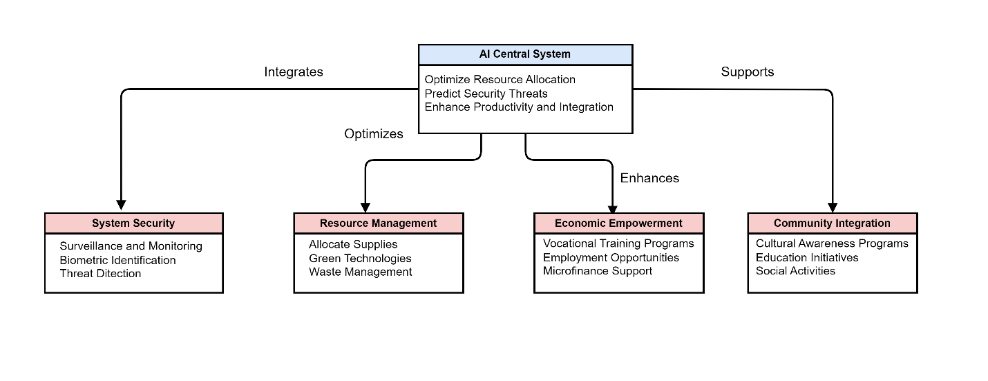

Figure 3 – Diagram of Proposed Ai driven accommodation system for Rohingya refugees